TASK 2 – GIT & GITHUB
DevOps Weekly Learning & Practical Work Report
Git repository management • GitHub remote • Push/Pull • Revert • Reset

Task | Task 2 – Git & GitHub
Repository | DevOps-Demo
Branch | main
Purpose | Documenting practical Git/GitHub learning and commands performed

1. Objective
The objective of this week's task was to connect a local Git repository with GitHub and practice the basic Git operations used in a DevOps workflow. The practical work included configuring a remote repository, pushing and pulling changes, examining commit history, working with reset, and using git revert to safely undo a previous commit.

2. Work Completed
- Connected the local repository to the GitHub repository named DevOps-Demo.
- Worked with the main branch and the remote named origin.
- Used git push to upload local commits to GitHub.
- Used git pull origin main to bring remote changes into the local repository.
- Used git log --oneline to inspect the commit history.
- Practiced git reset --soft HEAD~1 and observed how it changes the commit position while keeping changes staged.
- Created and resolved a merge/revert conflict in hello-world.txt.
- Completed a git revert operation and pushed the resulting revert commit to GitHub.
- Observed how local and remote branches can diverge and how pull/merge operations integrate histories.

3. Commands Used and My Understanding
git remote add origin <GitHub-URL>
Adds a remote repository and gives it the short name origin. In this work, origin refers to the GitHub repository used by the local DevOps-Demo project.
git push
Uploads local commits to the configured remote repository. The screenshots show successful pushes from the local main branch to GitHub's main branch.
git pull origin main
Fetches the latest commits from the main branch of the origin remote and integrates them into the current local branch. In the work shown, Git reported that a merge was made and README.md was created locally from the remote changes.
git log --oneline
Displays the commit history in a compact one-line format. This was used to inspect commit IDs, branch pointers, and the sequence of changes.
git reset --soft HEAD~1
Moves HEAD back by one commit while keeping the changes from that commit staged. This is useful when the commit needs to be recreated with a different message or combined with other changes. Unlike a hard reset, the working-file contents are preserved.
git commit -m "Merge the changes from the remote repo"
Creates a new commit with the supplied message. In the screenshot, this commit records the merge-related changes after the local and remote histories had diverged.
git revert <commit-id>
Creates a new commit that reverses the changes introduced by an earlier commit. It does not erase the old commit from history. This is the safer approach when changes have already been shared with a remote repository.
git revert --continue
Continues a revert operation after conflicts have been resolved and the affected files have been staged. The screenshot shows the command completing the revert and creating the revert commit.
git add .
Stages the current changes in the repository so they can be included in the next commit.
git status
Shows the current branch, staged/unstaged changes, and whether the local branch is ahead of or behind its remote-tracking branch.

4. Understanding origin and the Remote Repository
A Git remote is a named reference to another Git repository. The name origin is simply the conventional default name given to the first remote added to a local repository. It is not a special server or command by itself.
In this practical work, the remote points to the GitHub repository:
https://github.com/sathy.../DevOps-Demo.git
The terminal also showed an attempt to add the same remote again, followed by the message "remote origin already exists." This demonstrates that origin had already been configured.

5. Practicing git push
The git push operation was successfully used several times. Git transferred the local objects to the GitHub repository and updated the remote main branch. The terminal output included the destination GitHub URL and confirmation that main was updated.
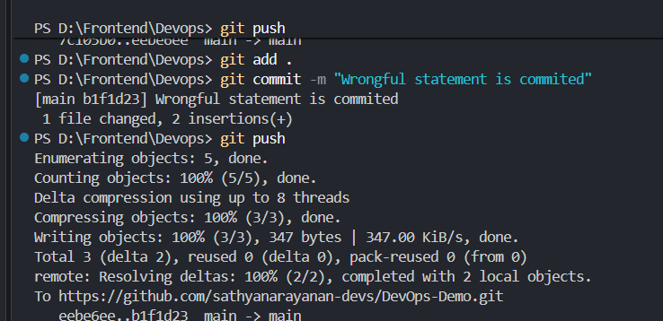
Figure 1 – Successful git push from the local repository to GitHub.

6. Practicing git pull
The command git pull origin main was used to retrieve changes from GitHub. The output showed that Git fetched the remote main branch and merged the changes using the configured merge strategy. README.md was created as part of the remote changes.
git pull origin main
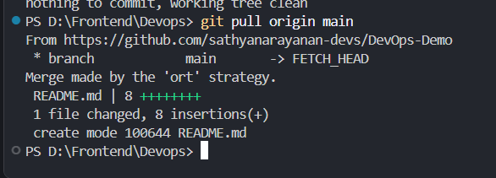
Figure 2 – Pulling remote changes from origin/main into the local repository.

7. Understanding git log --oneline
The compact commit history helped identify the sequence of work. The history included commits for the README, weekly task document, hello-world.txt changes, reset practice, and the later revert operation. The entries also showed HEAD and the origin/main references.
git log --oneline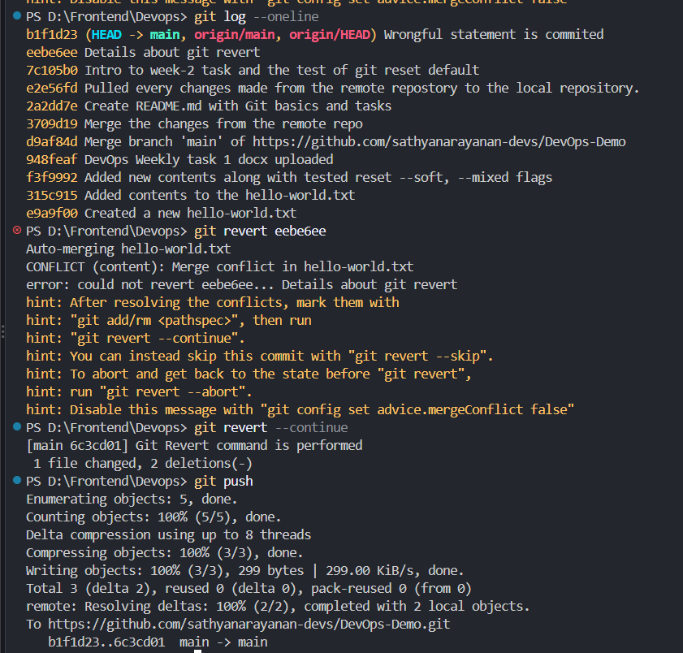

Figure 3 – Compact Git commit history showing HEAD and origin/main.

8. Practicing git reset --soft
The command git reset --soft HEAD~1 was practiced to move the current branch pointer back by one commit while preserving the changes from that commit in the staging area. The changes could then be committed again with a new commit message or combined with other changes.
git reset --soft HEAD~1
The screenshots also show that after the reset practice, the repository history was adjusted and a new commit was created to record the merged changes.

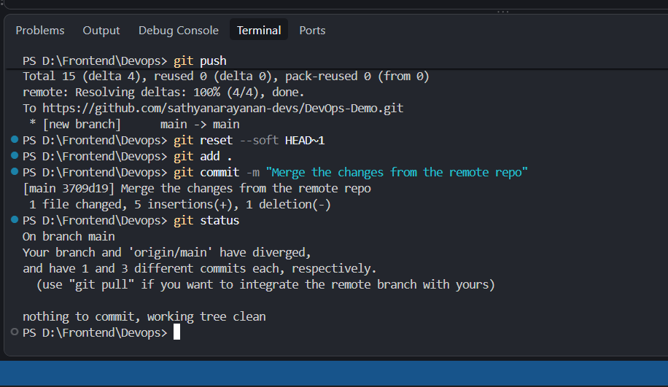
Figure 4 – git reset --soft practice and the subsequent commit.

9. Practicing git revert and Resolving a Conflict
A revert was attempted on the commit eeb e6ee (shown in the terminal as eebe6ee). Git attempted to automatically merge the reverse changes but reported a content conflict in hello-world.txt. This was useful practical experience because a revert can itself require conflict resolution when later changes overlap with the changes being reversed.
git revert eebe6ee
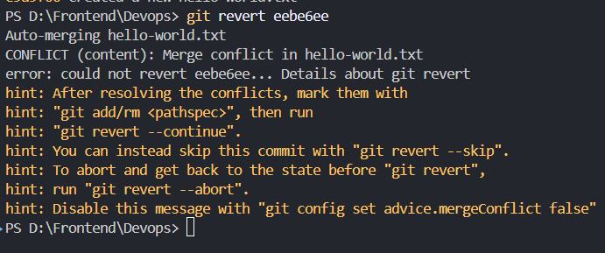
Figure 5 – git revert reporting a content conflict in hello-world.txt.
After the conflict was handled, the revert operation was continued with git revert --continue. The terminal then reported a new revert commit named "Git Revert command is performed" and showed that one file was changed.
git revert --continue

Figure 6 – Revert conflict resolved and the revert commit completed.

10. Pushing the Revert Result to GitHub
After the revert commit was created locally, git push was used to publish the new commit to GitHub. The terminal confirmed that the main branch on the remote was updated.
Figure 7 – Successful push of the revert commit to the GitHub main branch.

11. GitHub Repository Verification
The GitHub repository page was checked after the operations. It showed the DevOps-Demo repository on the main branch with files including the weekly task document, README.md, and hello-world.txt. This verified that the local work had been transferred to the remote repository.
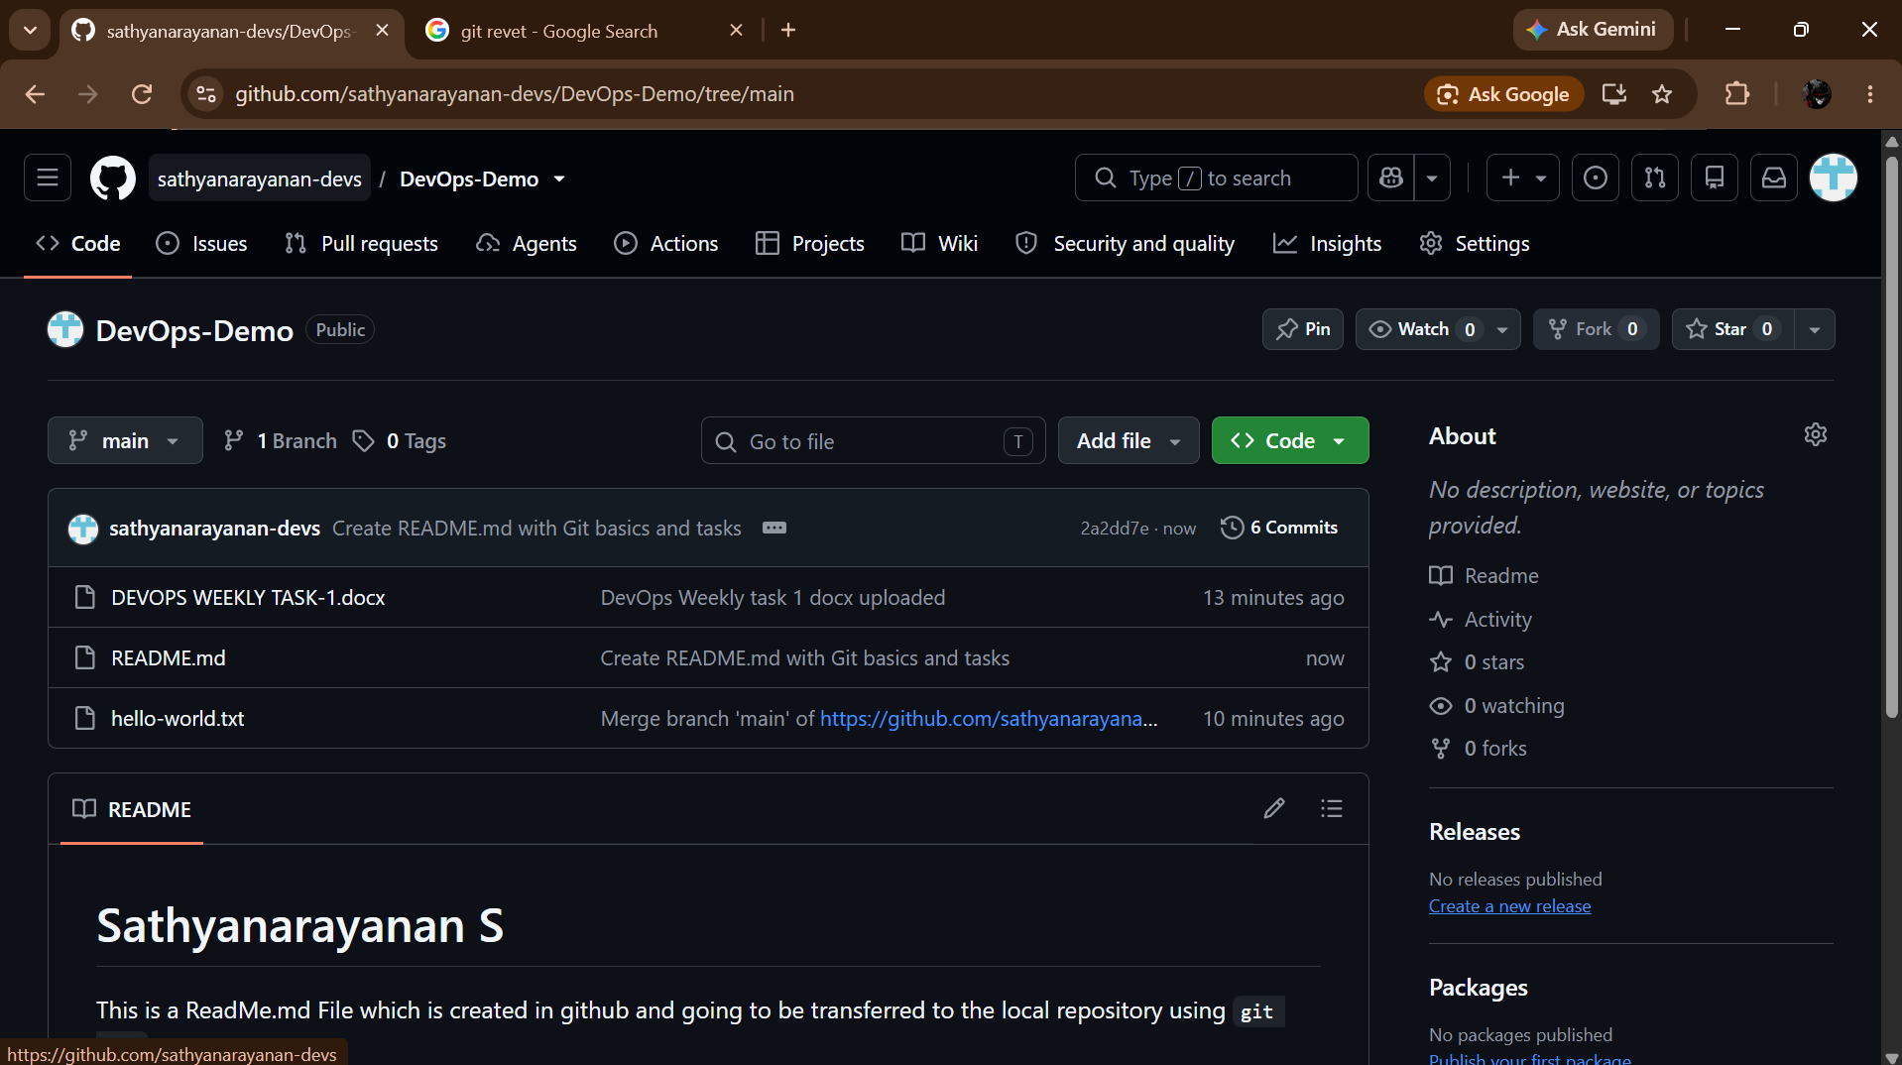
Figure 8 – GitHub DevOps-Demo repository showing the pushed files on main.

12. git revert vs git reset
Aspect | git revert | git reset
What it does | Creates a new commit that reverses an earlier commit. | Moves the current branch/HEAD to another commit.
Existing history | Keeps the original commit in history. | Can remove commits from the current branch history.
Shared branches | Generally suitable for changes that have already been pushed/shared. | Use carefully on shared branches because it can rewrite branch history.
Working changes | Produces a new inverse change. | Effect depends on the reset mode: --soft keeps changes staged, --mixed keeps them unstaged, and --hard discards tracked working-tree changes.
Used in this task | Yes. A revert conflict was resolved and the resulting revert commit was pushed. | Yes. git reset --soft HEAD~1 was practiced.

13. Key Understanding Gained
- Git tracks changes through commits, while GitHub provides a remote repository where those commits can be shared.
- origin is a local name that points to the configured remote GitHub repository.
- git push sends local commits to the remote; git pull retrieves and integrates remote changes.
- git log --oneline is useful for quickly understanding commit history and branch positions.
- git reset changes where the current branch points; the effect on files depends on the reset mode.
- git revert creates a new commit that reverses an earlier commit, preserving the existing history.
- A revert can produce merge conflicts when the target commit's changes overlap with later modifications.
- Resolving a conflict and running git revert --continue completes the revert process.
- The final git push publishes the new local commit, including a revert commit, to GitHub.

